HANDOUT 1: GETTING STARTED IN SPSS

Opening SPSS

* Click  🡪 **All apps** 🡪 **IBM SPSS Statistics** 🡪 **IBM SPSS Statistics 23**
* A message may appear regarding “Unicode Mode” 🡪 Click **Use Unicode encoding**
* A dialogue box will pop up giving you some SPSS data files to choose from. Click **Cancel**. This will open a new spreadsheet.
* Two tabs are located at the lower left corner of the spreadsheet, labeled **Data View** and **Variable View**. By default, SPSS opens in **Data View**. You can access the two spreadsheets by clicking on their respective tabs.
  + **Data View** contains the data and will be the view that you work from most frequently when conducting analyses.

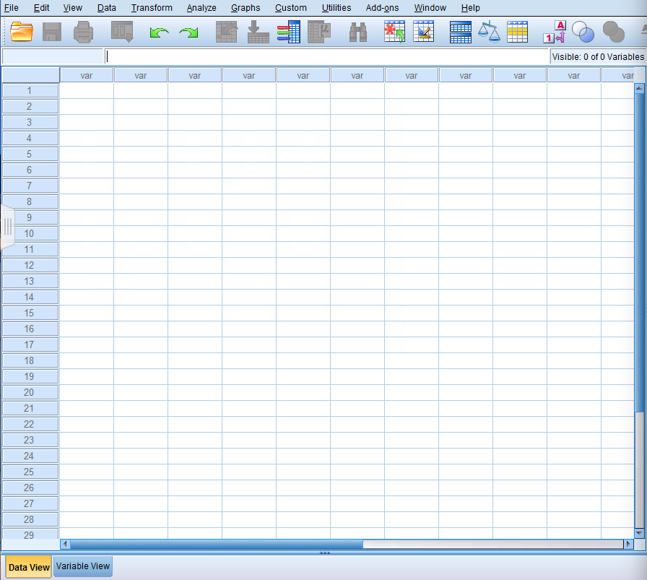

* + **Variable View** contains the specifications of your variables and will be the view that you use when first setting up your spreadsheet and entering the data.

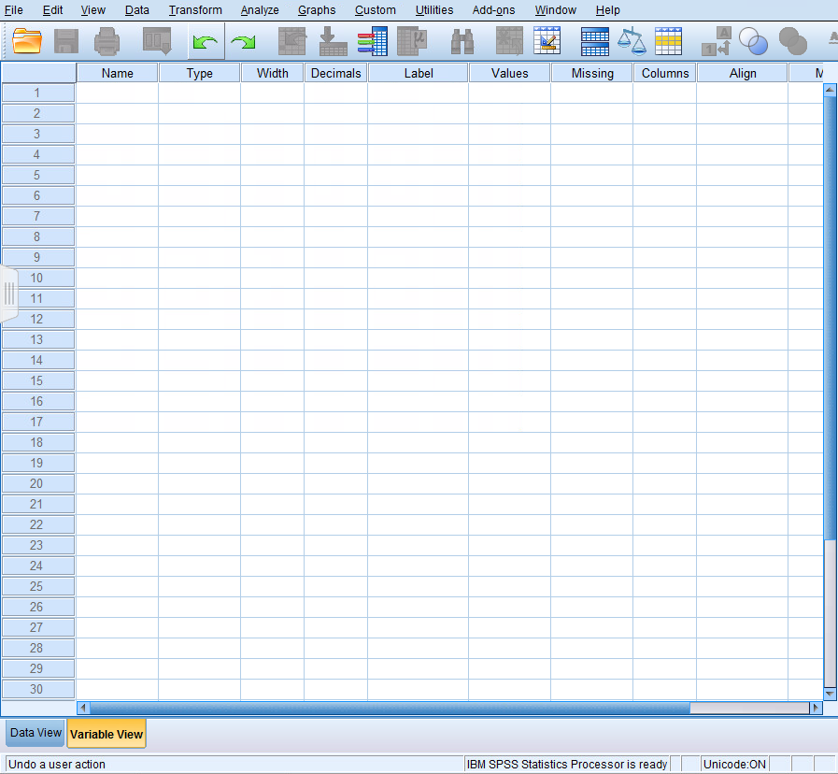

# Using SPSS – Basic Data Entry, Saving Files

## I. DEFINING VARIABLES

* In the **Variable View** spreadsheet, the *columns* are the characteristics of the variables in your dataset, which need to be defined. The *rows* represent the number of variables in your dataset. If you have 10 variables in your dataset, you will define 10 rows in the **Variable View**. The **Variable View** characteristics appear as follows:

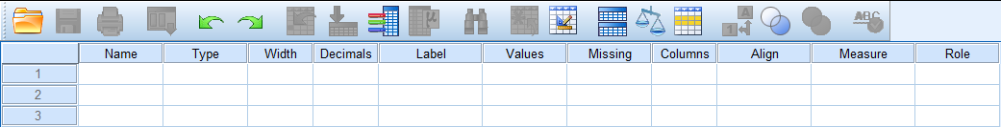

* Define your variables as follows (**\*\*Indicates action required**):

|  |  |  |
| --- | --- | --- |
| **Variable Specification** | **What is it?** | **How to Define** |
| Name** | Variable name | Type in the name (8 characters max) |
| Type | Variable type  (i.e., number, string, date) | Click on box (Numeric for numbers, String for letters, Other types but less common) |
| Width | Maximum variable length  (# characters) | Type in, accept default setting, or click on arrow |
| Decimal | Number of decimals in variable | Type in, or accept default setting |
| **Label\*\*** | Variable label (allows for more description than 8-character name) | Type in, or leave blank |
| **Values\*\*** | Variable value for quick entry  (i.e., M and F for Male and Female) | Click on box and follow prompts in dialogue box |
| Missing | Missing value designation | Type in, or accept default setting |
| Column | Width of column  (visual only; unrelated to # chars.) | Type in, accept default, or click on arrow |
| Align | Alignment within cell  (right, left, center | Click on arrow, or accept default |
| Measure | Measurement Level  (scale for numbers, nominal for strings or categories, ordinal for categories w/ some intrinsic order (i.e., low, medium, high) | Click on arrow or accept default |

**II. ENTERING YOUR DATA**

* Once the variables are defined, you can enter your data.
* In the **Data View**, each *row* represents a case or subject and each *column* represents a variable (notice that the columns bear the names of the variables you have defined).
* To enter data, simply click on the cell, and type in your score for that variable. Use [tab], [enter] or arrow keys to move between cells. Notice that you are entering your score for each variable or question from the questionnaires. You should end up with one long ***row*** of data. For example:

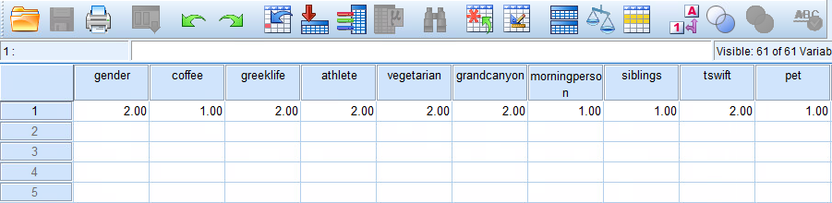

**III. SAVING YOUR FILE**

* Along the menu bar at the top of the screen, click **File** 🡪 **Save As**

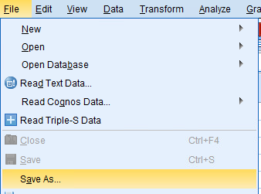

* In the Dialog Box:
  + Save to your H: drive
  + “File name” should be [yourlastname].sav
  + For “Save as type” accept the default (should be *.sav which indicates a SPSS data file).

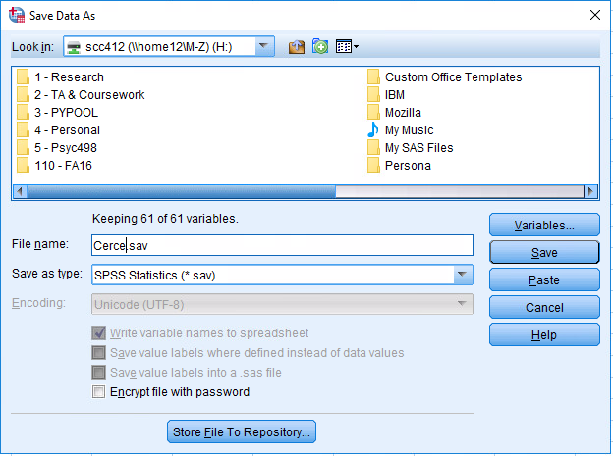

**IV. WHAT TO TURN IN**

* Once you have entered all of your data from the questionnaire, email [yourlastname].sav (SPSS) file to your TA (Wyntre – was214@lehigh.edu).
* **Hand in the hard copy of your class survey at end of class**.